James Dumitru

IIT PSYC 203

Project 3

PART 1

1.&2.) Recoded where "MajorRecode" is where it displays all those born within January to April = 1 , May to August = 2, and September to December = 3, and Default = NA.

(LabSurvey$MovieTrivia, LabSurvey$MajorRecode, stat.desc)

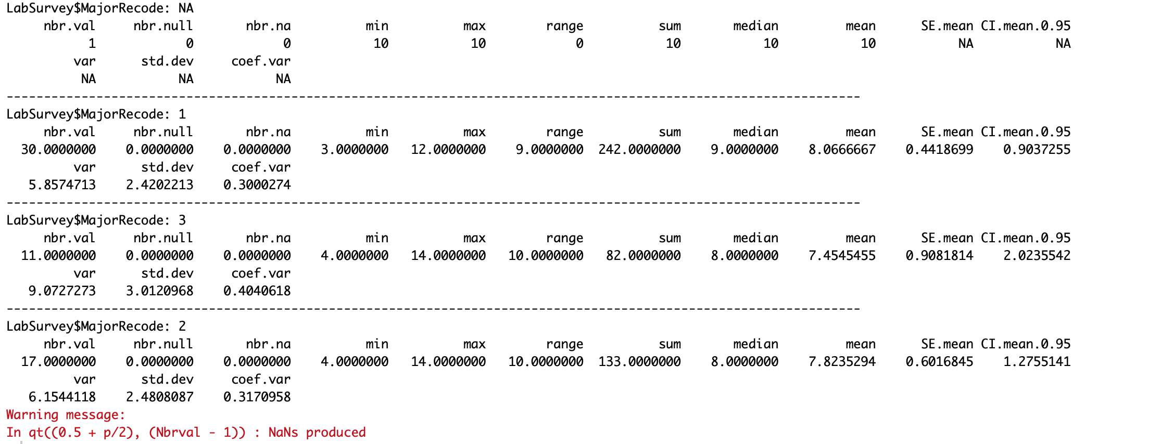

(LabSurvey$StatsEfficacy, LabSurvey$MajorRecode, stat.desc)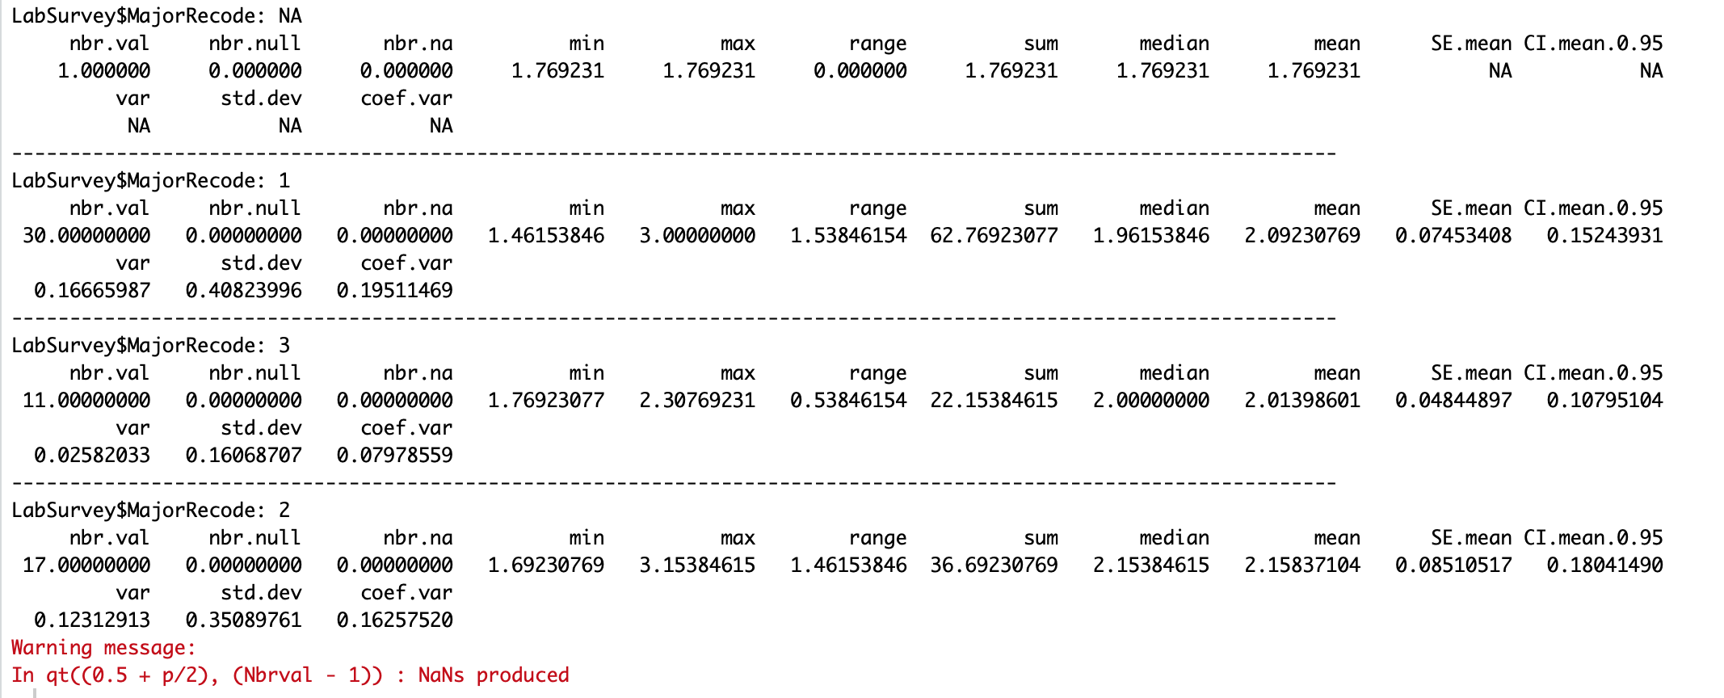

All worked to have a birthday shown except for one anomaly as NA on number 17. Other that that the data shows that there are more birthdays from the beginning of the year from January

To April with 30 results coming up as 1. Then 17 results for May to August coming up as 2 and 11 results for September to December as 3. I want to say

PART 2

Average Exam Scores were created. As well as the grouped mean and grouped mean exams.

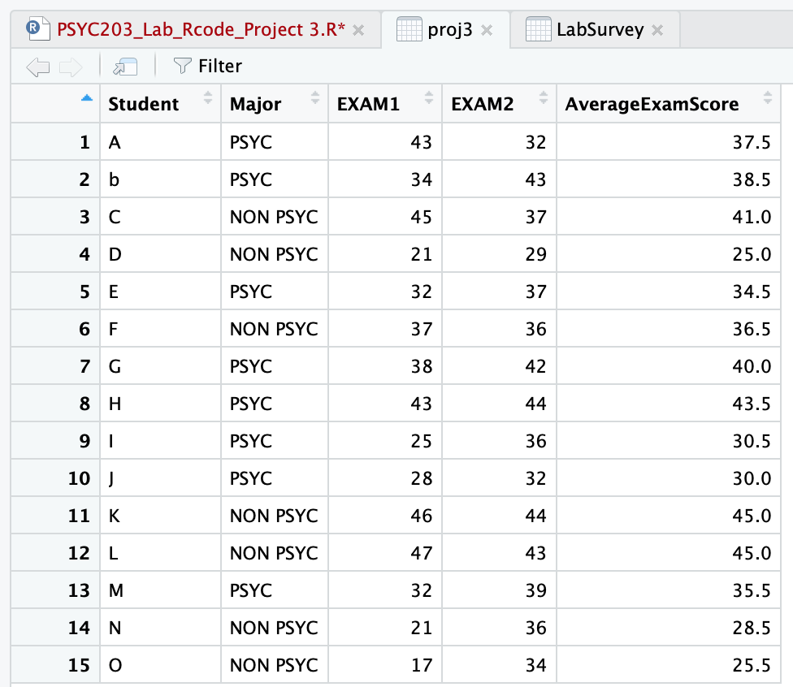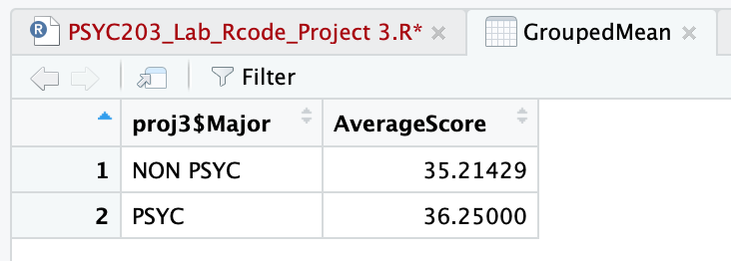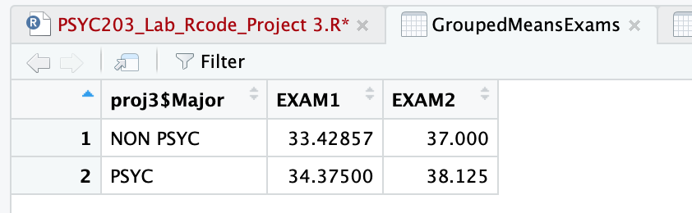

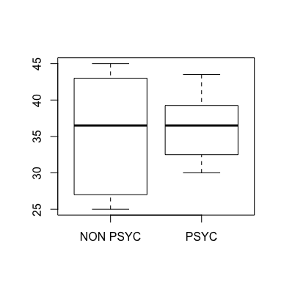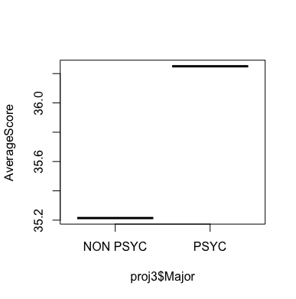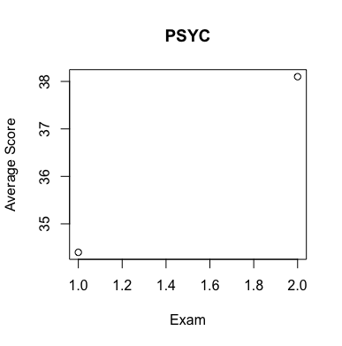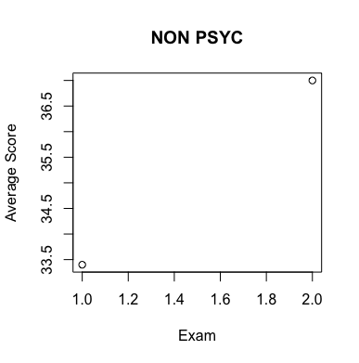

I was unsure as to why the plots come looking like this, if possible, I would want to know if this is even correct at all for the Psyc and Non-Psyc plots. I used barplot in case of anything as well.

